

HOW TO – GDMA Windows Target Configuration
(GroundWork Distributed Monitoring Agents V2.1)

Jan 21, 2010
Version 1.0

Prepared by:

Kevin Stone
Table of Contents
Summary 3
Prerequisites 3
GroundWork Monitor Setup 3
Create Monarch Monarch Group for Windows GDMA targets 3
Configure Monarch Group for Windows GDMA targets 4
Upload and Import GDMA Windows Base OS Host and Service Profile 6
Review and Modify gdma-windows host externals properties 8
Configure A GDMA Windows Host 9
Add new host to Monarch Group 10
Commit changes and Build Externals 11
Install GDMA Agent on Target Error! Bookmark not defined.
Additional Information 12

Summary

This document describes the steps necessary to configure GDMA agents for Windows systems. This document describes a basic installation. For information on advanced configurations contact Groundwork support.

Prerequisites

The following prerequisites exist for configuring Windows GDMA Agents:

- GroundWork Monitor Enterprise 6.0.1 correctly installed.
- GroundWork Monitor GDMA Master Server Configuration complete.
- Administrative access to Groundwork and Target systems and familiarity with Groundwork, Nagios and Monarch
- Taking a backup of the monarch database is highly recommended before beginning this operation See Bookshelf →System Maintenance→Backup and Restore for details

GroundWork Monitor Setup

Create Monarch Monarch Group for Windows GDMA targets
In Configuration→Groups→
  - Select New
  - Fill in Group Name field E.G. “windows-gdma”
  - Select Add to create the monarch group.

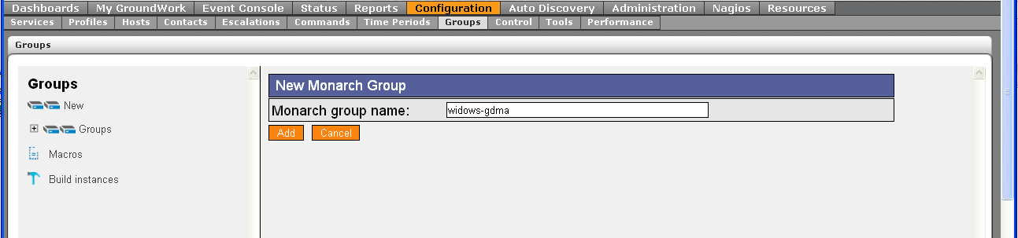

Configure Monarch Group for Windows GDMA targets
Monarch groups are used to control creation of monarch external definitions used by GDMA agents.

In Configuration→Groups→
- Expand Groups
- Select or create group windows-gdma (or similar name)
- Select detail page of windows-gdma
- Fill in Description[Optional]
“Monarch group for configuration of gdma targets”
- Fill in Build directory
“/usr/local/groundwork/apache2/htdocs/gdma”
- Leave all other fields blank
- Select Save
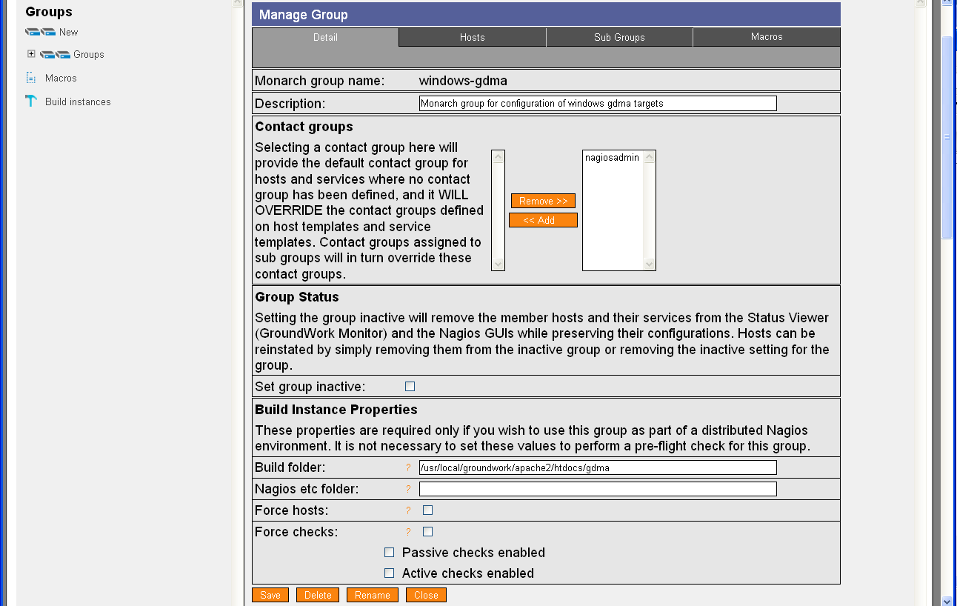
- Select the windows-gdma group, Details, then Macros
- If the Plugin_Directory macro has been added to the windows-gdma group, you may remove it, as GDMA will substitute the value of the Poller_Plugin_Directory parameter at runtime. If you prefer to use the Plugin_Directory macro, change the value of the Macro to c:\program files\gdma\libexec (or to the directory where the windows gdma is installed, with the \libexec appended).

Upload and Import GDMA Windows Base OS Host and Service Profile
The Windows Base OS profile provides configuration parameters for the creation of Windows targets.
If you are upgrading from a previous version, you must first remove any files of the same name as those to be uploaded from the /usr/local/groundwork/core/profiles directory.

In Configuration→Profiles
- Select Profile importer
- Scroll to bottom of screen
- Select Browse and enter location of “gdma-windows-base-os.xml”
- Select upload
- Select Browse and enter location of “service-profile-gdma-windows-base-os.xml”
- Select upload
- Select Browse and enter location of “perfconfig-gdma-windows-base-os.xml”
- Select upload

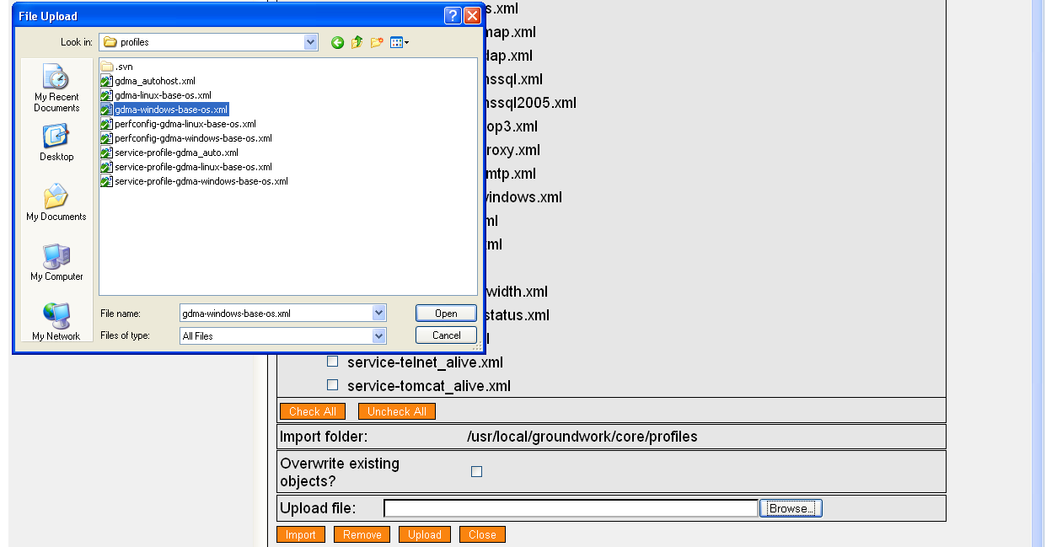

- Toggle Checkbox for gdma-windows-base-os.xml

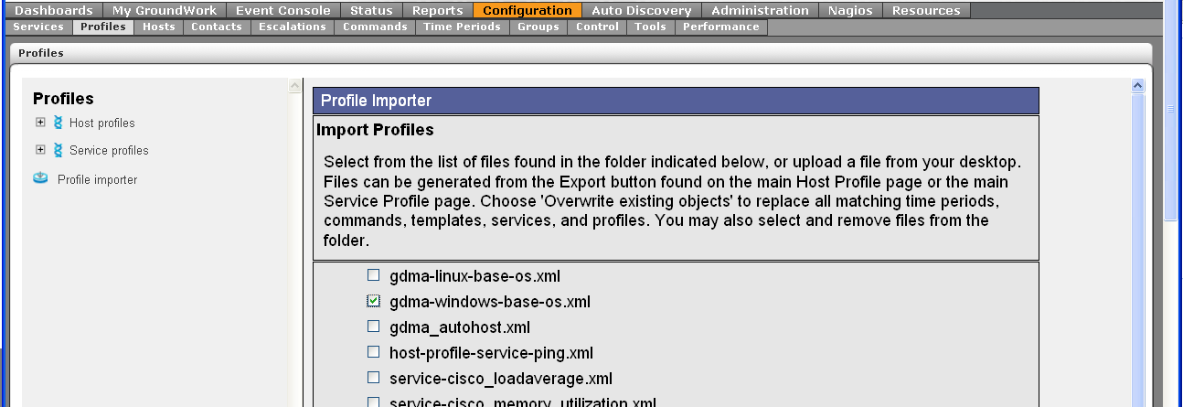
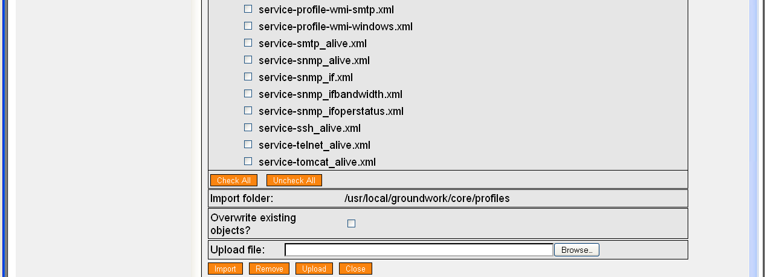

- If upgrading, select Overwrite Existing Objects. Select Import.

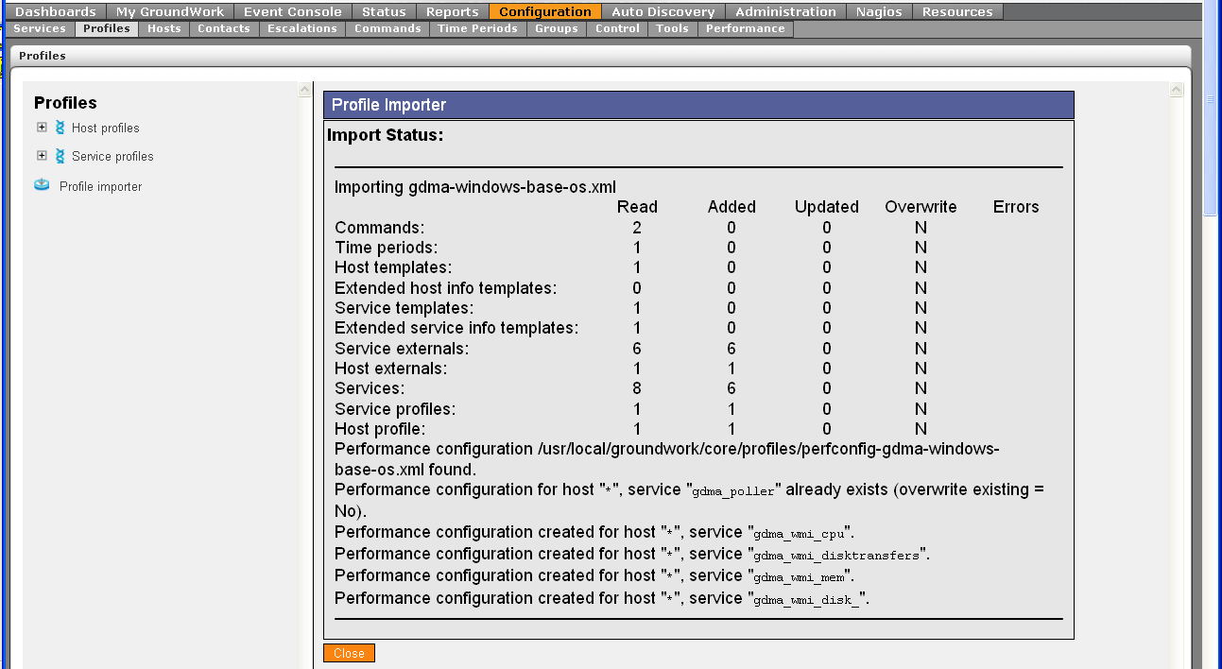

Review and Modify gdma-windows host externals properties
In Configuration→Hosts→Host Externals
- Select Modify
- Select gdma-windows

Modify Target_Server parameter
This parameter controls where GDMA agents will download their configurations from and where they will send check results. The parameter must be in the form of a url. This parameter is normally set to the hostname or ip address of the Master system. For details on this and other configuration parameters see GDMA Agent Configuration Reference.

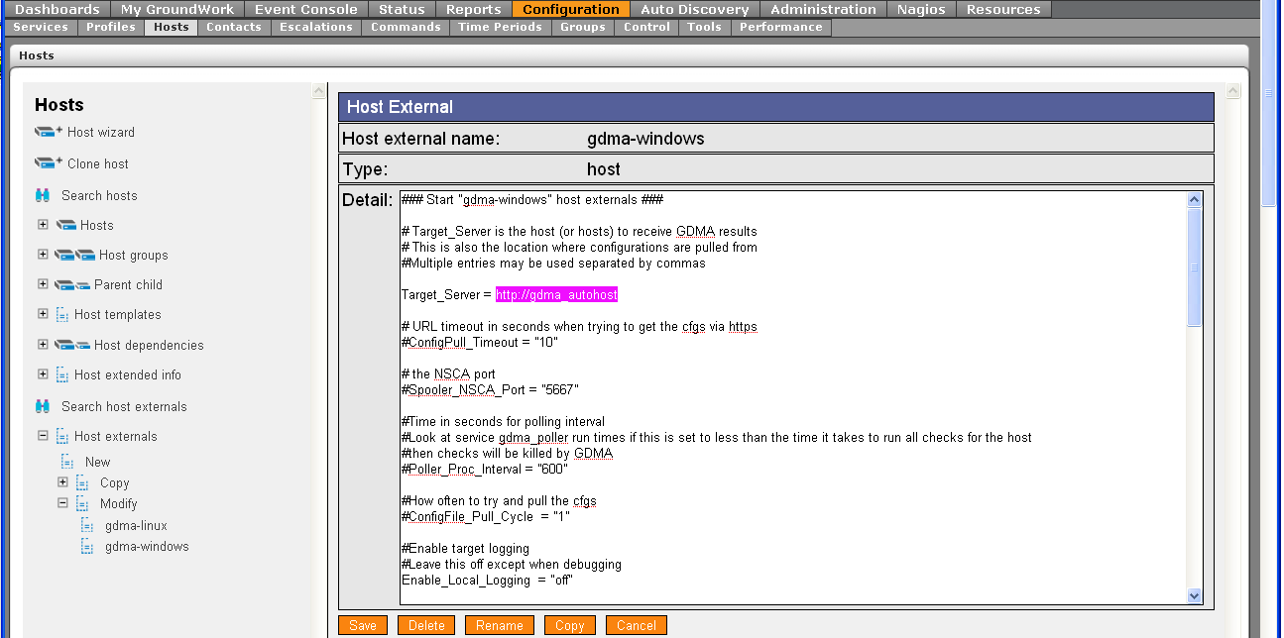
- Select Save.
- If upgrading from a previous version of Windows GDMA, select Apply to Hosts, and do the following steps:
  - Select Services, Service Externals, Modify
  - For each Service external beginning with “gdma_wmi”, open the external
  - Select Save
  - Select Apply to Services

Configure A GDMA Windows Host

In Configuration→Hosts
- Select Host Wizard
- Fill in Host Name E.G “2000pro”
- Fill in alias E.G.“2000pro”
- Fill in address E.G.“196.168.11.72”
- Select gdma-windows-base-os Host profile

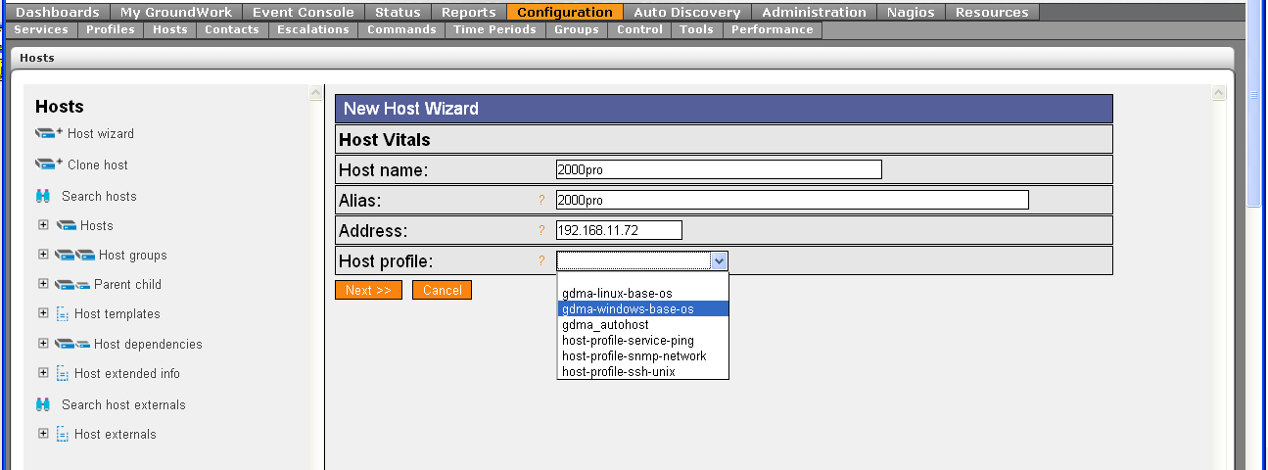

- Select Next,Next,Next,Next,Continue

Add new host to Monarch Group
In Configuration→Groups
- Expand Groups
- Expand windows-gdma
- Select Detail
- Select Hosts Tab
- Toggle Checkbox for host E.G. 2000pro
- Select Add Hosts
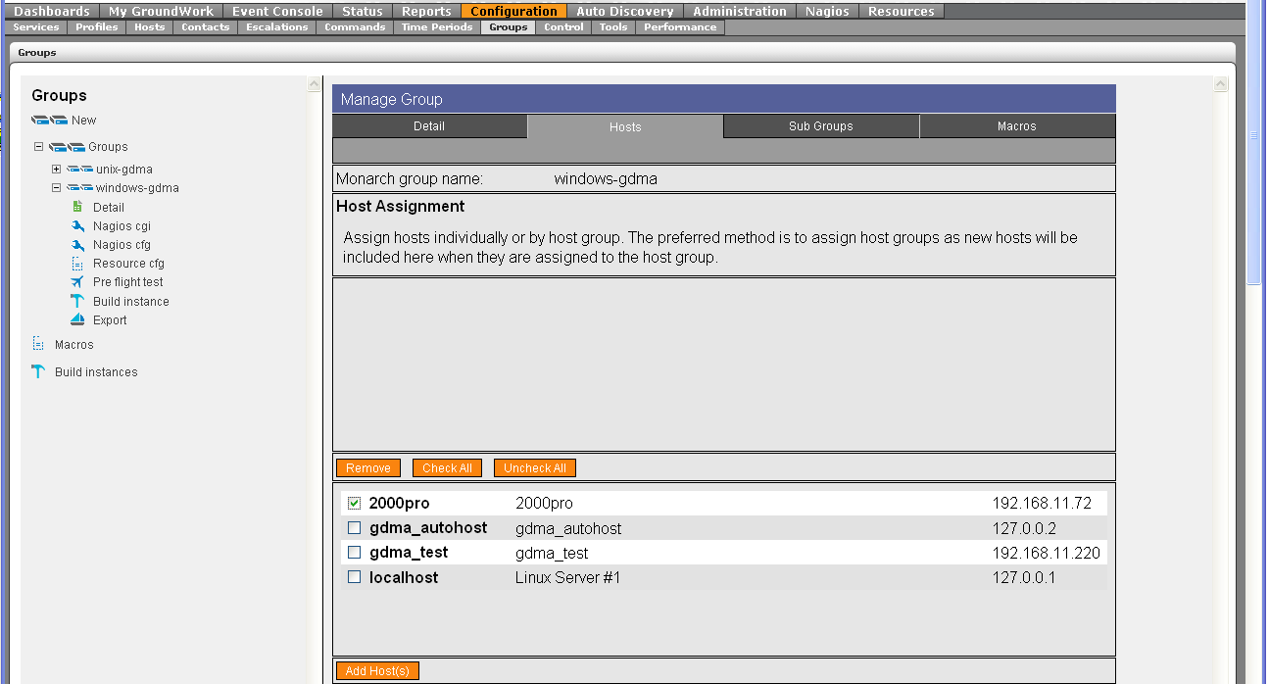

Host will appear in the upper field as an assigned host.

Commit changes and Build Externals
To commit changes to groundwork and create gdma configuration file

In Configuration→Control
- Select Commit, Backup, Commit
- Select Run externals

The configuration file will be created in “/usr/local/groundwork/apache2/htdocs/gdma” as defined in the windows-gdma monarch group. The filename will be gwmon_$hostname.cfg in this example gwmon_2000pro.cfg

#ls -al /usr/local/groundwork/apache2/htdocs/gdma/gwmon_2000pro.cfg
-rw-r--r-- 1 nagios nagios /usr/local/groundwork/apache2/htdocs/gdma/gwmon_2000pro.cfg
#

Additional Information
GDMA Autoconfiguration
GDMA Master Server Howto
GDMA Linux Target Howto
GDMA Configuration and Installation Reference

See Bookshelf Using Applications→Configuration→Configuration Scenarios→Configuring Externals
This directory is controlled by the GDMAConfigDir Configuration parameter. Do not modify this path without consulting GDMA agent documentation.
You may optionally place the host in a hostgroup and configure additional host, service and notification options.

